 Indian School Al Wadi Al Kabir
Assessment 2
INFORMATICS PRACTICES (Code: 065)

 | SECTION A
1. | C | 1
2. | B | 1
3. | B | 1
4. | C | 1
5. | D | 1
6. | B | 1
7. | C | 1
8. | B | 1
9. | A | 1
10. | D | 1
11. | del ODD[9]/ ODD.pop(9) | 1
12. | A | 1
13. | A | 1
14. | B | 1
15. | A | 1
16. | A | 1
17. | D | 1
18. | B | 1
19. | C
20 | B - Both A and R are True, but R does not correctly explain A.
21. | A - Both A and R are True, and R correctly explain A.
 | SECTION B
22. | - Primary key constraint is similar to unique constraint except that only one column can be applied in this constraint  - The primary key cannot allow NULL values, thus this constraint must be applied to columns declared as NOT NULL | 2
23. | Create table shop(Fno int(10) primary key, Fname varchar(15) unique, Type char(10), stock int(3), price float(10,2) not null); | 2
24. | - "s1" in School  - len(School)  - School["s5"] = 99  - School.items() | 2
25. | - 10  - [62, 14, 62, 14, 62, 14]  - False  - [1007, 14, 62, 45, 98, 98] | 2
26. | A. show databases;  B. use school; | 2
27. | DELETE is DML command while DROP is a DDL command. Delete is used to delete rows from a table while DROP is used to remove the entire table from the database. | 2
28. | num=int(input("Enter the number:"))  fact=1  i=1  while i<=num:  fact=fact*i  i=i+1  print("Factorial=",fact) | 2
 | SECTION C
29. | final x= 9  sum = 25  product= 945 | 3
30. | - To speed up the operations of the CPU, a very high-speed memory is placed between the CPU and the primary memory known as cache. It stores the copies of the data from frequently accessed primary memory locations.  - Windows, Linux, Macintosh, Ubuntu, Fedora, Android, iOS, etc.  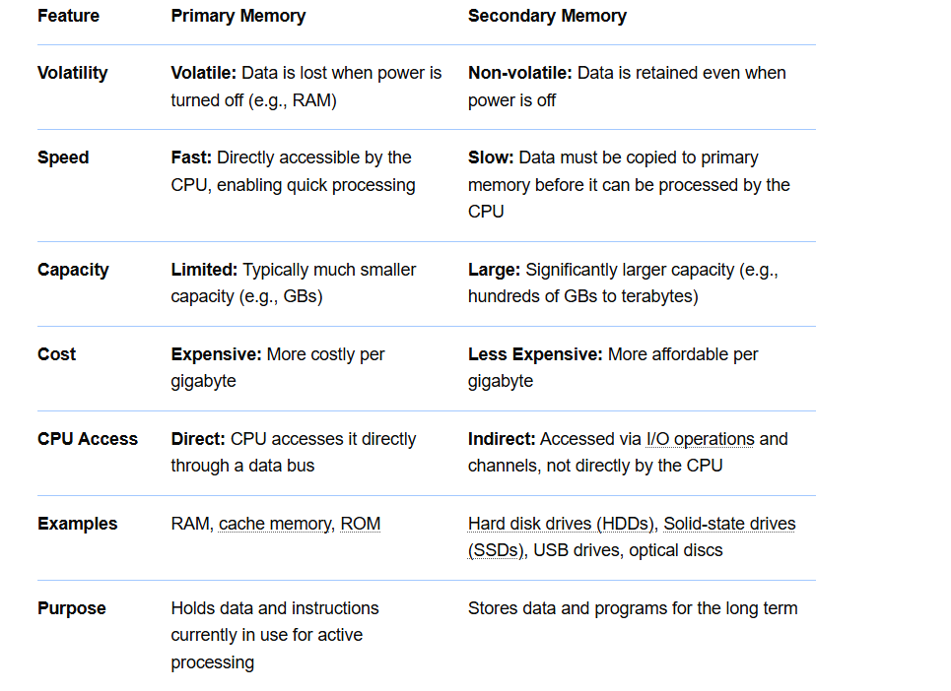 | 3
31. | L1=eval(input(“Enter the list elements:”))  sum_even = 0  sum_odd = 0  for num in L1:  if num % 2 == 0:  sum_even += num  else:  sum_odd += num  print(“Sum of even numbers=”,sum_even)  print(“Sum of odd numbers=”,sum_odd) | 3
32. | 40  30  [20, 30, 50, 40, 50, 30, 10, 20, 60]  10  [20, 30, 50, 40, 50, 100, 30, 10, 20, 60, [15, 78]]  2 | 3
 | SECTION D
33. | Month = {}  for i in range(12):  name = input("Enter the name of the month: ")  days = int(input("Enter the number of days in this month: "))  Month[name] = days  print("\nMonth Dictionary:")  print(Month)  search = input("\nEnter the name of the month to know its number of days: ")  if search in Month:  print("Number of days =", Month[search])  else:  print("Month not found in the dictionary!") | 4
34. | 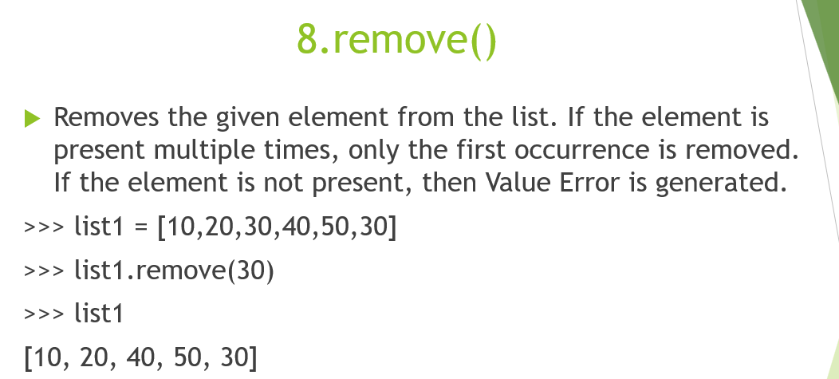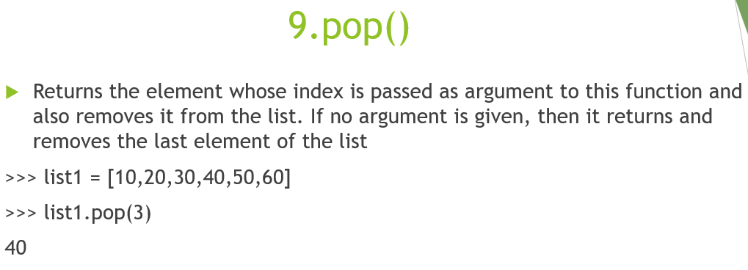  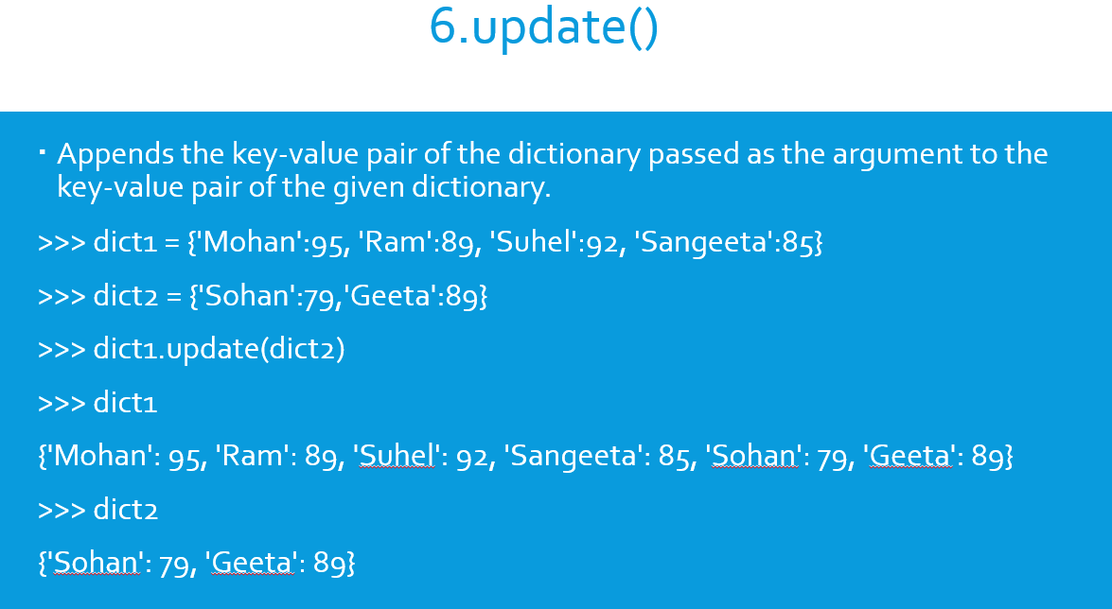  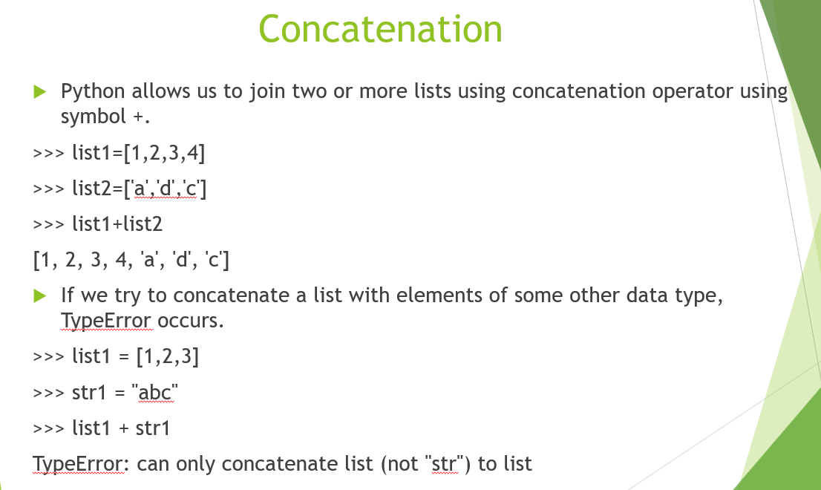  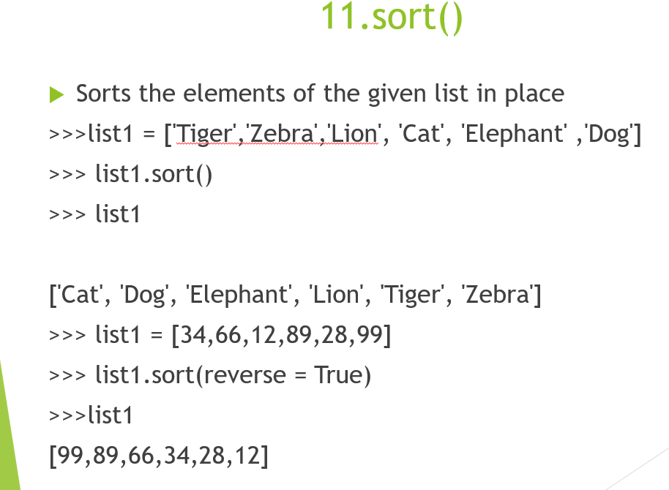 | 4
 | SECTION E
35. | - SELECT * FROM EMP WHERE JOB IN (‘CLERK’, ‘SALESMAN’);  - SELECT ENAME, JOB FROM EMP;  - SELECT DISTINCT JOB FROM EMP;  - SELECT ENAME FROM EMP WHERE DNAME IS NULL;  - DELETE FROM EMP; | 5
36. | (i) Select name from result where division=’First’ order by name;  (ii) Select name, subject, stipend from result;  (iii) Update result set stipend=stipend+500 where average>65;  (iv) Insert into result values(7, "Mohan", 500, "English",73,"Second");  (v) | 5
  No | Name | Stipend | Subject | Average | Division
  1 | Sharon | 400 | English | 38 | THIRD
  2 | Amal | 680 | Mathematics | 72 | FIRST
  3 | Vedant | 500 | Accounts | 67 | FIRST
  5 | Anandha | 400 | History | 85 | FIRST
  6 | Upasana | 550 | Geography | 45 | THIRD
37 | - Alter table teacher add primary key(code);  - Alter table Teacher add Salary int;  - Alter table teacher drop experience;  - Select * from teacher where salary between 26 and 28;  - Delete from teacher where teachername like ‘%R%’;

